Statistics Lecture 7.5: Confidence Intervals for Variance and Std Dev. Chi-Squared Distribution

Estimating Population Variance 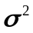:

Chi-squared: 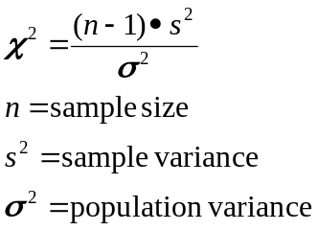

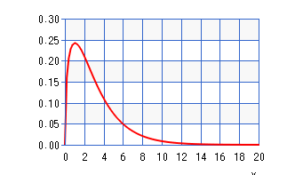
Chi squared distribution.
Not symmetrical.
All values are non-negative values >0
As degrees of freedom increase then distribution becomes increasingly symmetrical.
Gives critical values for the area to the right.
Example
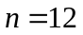, with a 95% confidence level find critical values.
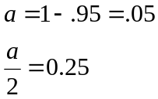
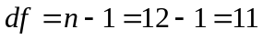
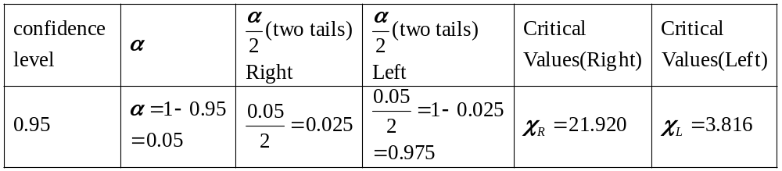
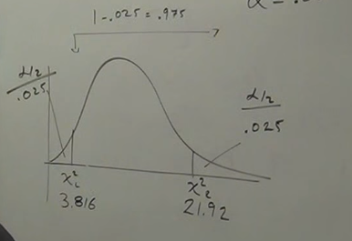
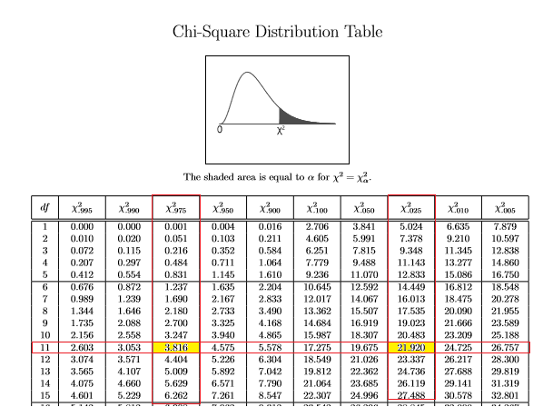
Confidence Intervals (variance):
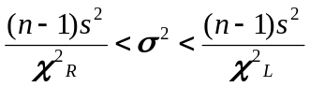

Confidence Intervals (Standard Deviation):
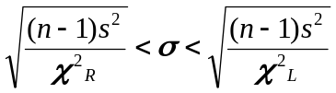
Example
Sample of 10 appliances, with a standard deviation of 0.15 volts.
Construct a confidence interval using a 95% confidence level for the Population Variance and
The population standard deviation
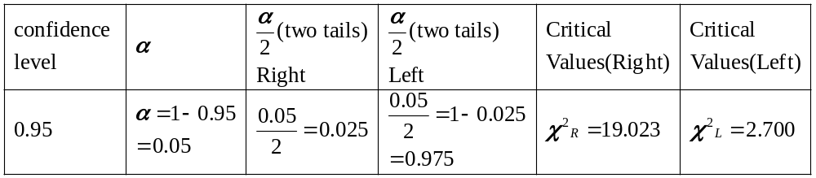
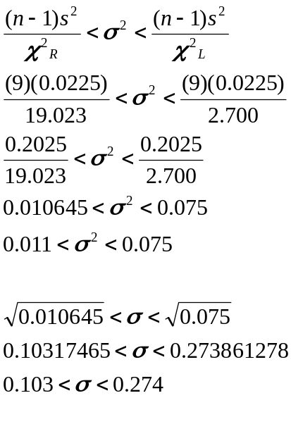
We do not know the population variance and the population standard variance, but I am 95% sure
That the population variance will be between 0.011 and 0.075 volts.
Also that I am 95% sure that the Population Standard deviation will be between 0.103 and 0.274 volts.

